New Website Overview

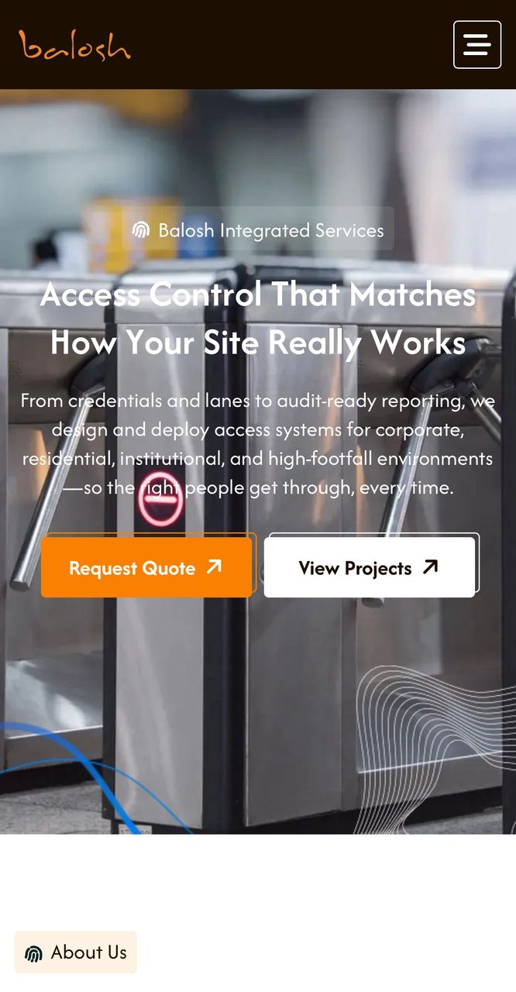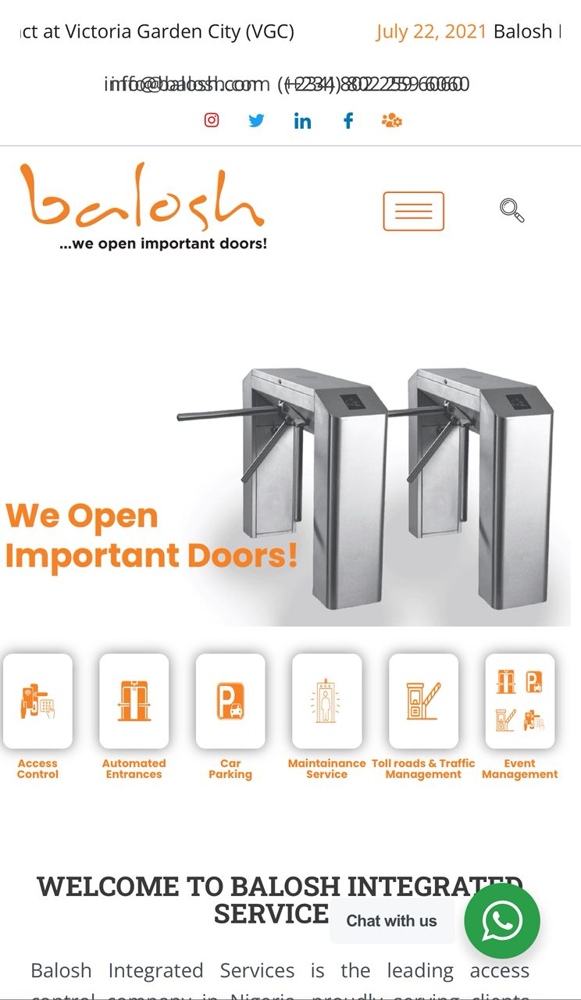
On the left side is the front page of the new website while the image on the right is the current website.
Note that the tagline “…..we open important doors” will be added to the logo and social media icons will be added to the header.
For easy understanding, the text on black are the new changes made, while that on grey is the information seen on the current website. Also, the red highlighted text are things required/needed from your team.

- About us:
- Who We Are;

Since 2005, Balosh Integrated Services Limited has built its reputation on three uncompromising pillars: reliability, credibility, and consistent industry leadership. For two decades, we have delivered trusted security and access control solutions across Nigeria’s most critical environments.

We provide fully integrated, end-to-end services, from design and development to installation and ongoing support, all managed in-house. This approach ensures seamless execution, accountability, and the highest standards of quality at every stage.

From major transport terminals handling millions of people to government institutions, corporate campuses, and leading retail destinations, Balosh has become a trusted name in securing and managing high-value spaces. Our solutions are built to perform in demanding environments, supporting efficiency, safety, and operational excellence.

The trust placed in us by Nigeria’s most important institutions has been earned through consistency, expertise, and results. It is a responsibility we take seriously, and one that continues to drive our commitment to delivering reliable, future-focused solutions.

(Current Website)
Balosh Integrated Services is the leading access control company in Nigeria, proudly serving clients since 2005. With a strong emphasis on the commercial sector, we have established ourselves as the most experienced and innovative provider in the industry. Our success is driven by our ability to understand the unique requirements of each client and our commitment to delivering unparalleled service and workmanship.

At Balosh, we believe that integrity and customer satisfaction are paramount. Our core values—customer-centricity, innovation, excellence, and teamwork—guide our operations and interactions, ensuring that we consistently exceed client expectations. Over the years, we have secured numerous high-profile contracts, enhancing our reputation as a trusted partner in access control solutions.

- History & Milestones; (Newly added)

Founded in 2005, Balosh Integrated Services has grown into a trusted leader in security and access control solutions, with nearly two decades of industry experience. Over the years, we have built a strong nationwide presence, supported by a team of over 100 skilled professionals dedicated to delivering excellence.

Our systems currently manage over 200,000 daily check-ins, reflecting the scale, reliability, and efficiency of our operations across various sectors. With a focus on innovation, Balosh utilizes OEM hardware specifically built to meet the demands of the Nigerian environment, ensuring durability, performance, and long-term value.

As we continue to evolve, our commitment remains the same, to provide advanced, reliable, and tailored solutions that support seamless operations and drive progress for our clients.

(Images of past and present outlets would be needed to show the growth process).

- Vision, Mission Statement & Core Values; What you currently have as Corporate Philosophy

Our Vision
Our philosophy is not just a set of statements; it’s a commitment to excellence in every interaction. At Balosh Integrated Services, we are dedicated to creating secure environments that empower businesses and communities, ensuring a brighter, safer future for all.

Our Mission
At Balosh Integrated Services, our mission is to be the leading provider of access control solutions, driven by a commitment to integrity, customer satisfaction, and innovation. Our foundational beliefs guide every aspect of our operations.

Core Values
- Integrity
We conduct our business with honesty and transparency, fostering trust with our clients and partners.

- Customer-Centricity
Our customers are our priority. We view our relationships as partnerships, actively seeking their feedback to tailor our solutions and ensure complete satisfaction.

- Employee Empowerment
We believe that our employees are our greatest asset. By investing in their professional development, recognizing their contributions, and promoting an inclusive environment, we create a motivated and engaged workforce.

- Innovation and Agility
We embrace a proactive approach to innovation, continuously adapting our strategies to meet the ever-evolving needs of the market. Our commitment to research and development, combined with an agile mindset, allows us to integrate the latest technologies and methodologies into our offerings.

- Community Engagement
We recognize our responsibility to give back to the communities we serve. Through outreach programs, sustainable practices, and support for local economies, we strive to make a positive impact while enhancing community safety through our innovative solutions.

- Excellence and Security
Our philosophy is not just a set of statements; it’s a commitment to excellence in every interaction. At Balosh Integrated Services, we are dedicated to creating secure environments that empower businesses and communities, ensuring a brighter, safer future for all.

- Our Team; What you currently have as Our people
Behind every door Balosh opens is a team of engineers, technicians, software developers, and support specialists who take personal ownership of client outcomes. At Balosh Integrated Services, our people are at the heart of everything we do. Their passion, expertise, and dedication drive our ability to deliver exceptional value in a competitive landscape.

We are committed to creating a work environment that is safe, respectful, and empowering, where collaboration thrives and every voice is heard. Through continuous learning, mentorship, and clear growth pathways, we equip our team with the tools they need to succeed and evolve.
Diversity and inclusion remain central to our culture. By embracing individuals from varied backgrounds, we foster a workplace that reflects the communities we serve and encourages innovation through different perspectives.

We also prioritize employee well-being by supporting both professional and personal growth, ensuring our team remains motivated, balanced, and inspired.

At Balosh, we don’t just build a business, we cultivate a dynamic environment where people can thrive, contribute meaningfully, and achieve excellence.

(Current Website)
At Balosh Integrated Services, our greatest assets are our people, and we take immense pride in their contributions. We rely on their enthusiasm, talent, and commitment to drive our success in today’s competitive market. Our employees are the cornerstone of our ability to deliver exceptional service to our customers.

We believe that a positive employee experience directly translates to superior customer service. To ensure this, Balosh is dedicated to fostering a work environment that is safe, promotes well-being, and treats everyone with respect. Our culture emphasizes teamwork and open communication, allowing all employees to share ideas and collaborate effectively. We prioritize professional development by offering comprehensive training programs, mentorship opportunities, and clear pathways for career advancement.

Diversity and inclusion are integral to our workplace philosophy. We actively seek to hire individuals from varied backgrounds, ensuring that our workforce reflects the communities we serve. Our inclusive policies and diversity training foster an environment where every employee feels valued and respected.

Employee well-being is a priority at Balosh. We offer wellness programs, flexible work arrangements, and resources such as Employee Assistance Programs to support mental health. Our social activities and team-building events help create a strong sense of community among our staff.
As we continue to grow, we remain committed to providing our employees with the tools and opportunities they need to thrive. At Balosh Integrated Services, we don’t just build a successful business; we cultivate a supportive and dynamic workplace where our people can excel.

(A group picture(s) of members of staff)

- Why Balosh? (We will maintain the same diagram)

- What Sets Us Apart (Newly added)
There are many vendors but there is only one Balosh.
Here is why Leaders Choose Balosh:

- Built for Nigeria’s Realities
Our systems are engineered to perform in demanding conditions, from power variability to large-scale, complex environments.

- End-to-End Accountability
We manage every stage in-house, from hardware and software to installation and ongoing support, ensuring seamless delivery and full responsibility.

- Propriety OEM Hardware
Our solutions are powered by hardware designed for Nigerian conditions, offering durability, faster parts access, and flexible customization.
- Global Technology, Local Expertise
We combine world-class technology with deep local insight to deliver solutions that truly work where it matters most.
- A Reputation Earned Through Results
For over 20 years, our clients have become our strongest advocates, driven by consistent performance and trust.

- Built for the Long Term
We don’t just deliver projects, we build lasting partnerships. Your uptime, reliability, and success remain our priority.

- Management Team: (Newly added)
Our management team brings together experience, strategic insight, and a shared commitment to excellence. With a clear vision and deep industry expertise, they drive Balosh’s growth while ensuring the consistent delivery of reliable, high-quality solutions across every project.

(Names, position and pictures of key managements, with a brief information about them comprising of their education and when they joined the company).

- Our Solutions:
At Balosh Integrated Services, we deliver tailor-made solutions built around the unique needs of every client. With expertise across multiple sectors, we combine innovation with the latest technology to provide services that are not only effective but also future-ready and reliable.

- Access Control: provides secure and scalable access management solutions that combine both hardware and software systems. It includes advanced biometric options such as fingerprint, facial recognition, iris scanning, and multi-modal authentication. These systems also integrate time and attendance tracking, visitor management, and workforce security features. The service is delivered end-to-end, covering design, installation, system integration, and ongoing support.

- Automated Entrances: focus on intelligent entry and exit systems such as automatic doors and gates, barriers, bollards, turnstiles, and roller shutters. These solutions are built to handle high-traffic environments while maintaining strong security integration. They can be seamlessly connected with access control systems, ANPR technology, and centralized dashboard monitoring for efficient oversight and control.

- Car Parking Solutions: delivers complete, end-to-end parking ecosystems that include design, supply, installation, operation, and maintenance. The systems feature automated barriers with ticketing, ANPR integration, and cashless payment options. They also provide real-time occupancy monitoring through digital dashboards, with flexible operational models such as leasing options where required.

- Toll Road Management: covers fully integrated toll plaza solutions, including both hardware and software systems. These support multi-lane toll processing with multiple payment methods such as cash, card, and RFID. The system provides real-time revenue reporting, detailed audit trails, and nationwide maintenance support, ensuring reliability across large-scale road infrastructure.

- Security Systems: offers comprehensive screening and threat detection solutions designed for high-security environments. These include walk-through metal detectors, baggage scanners, and under-vehicle inspection systems. The solutions are fully integrated with access control, CCTV surveillance, and incident management platforms, supported by end-to-end implementation and 24/7 operational assistance.

- Cross-cutting Capabilities: includes custom software development tailored to specific business needs, flexible equipment rental solutions to support varying project demands, and seamless system integration with API access that enables different platforms and technologies to work together efficiently.

(Current Website)
Solution; At Balosh Integrated Services, we pride ourselves on offering customized solutions designed to meet the unique needs of each client. Our expertise spans multiple areas, and we leverage the latest technologies to ensure our services are both innovative and effective.
All, Access Control, Car Parking, Entrance Control, Event Management, Maintenance Services, Toll Roads & Traffic Management.

- Tripod Bridge Turnstiles
- Linear Tripod Turnstiles
- Automated Ticketing Terminals
- Structured Parking Arrangement
- Digital Door Access
- Entrance Controls
- Rentals
- Maintenance Service
- Toll Roads & Traffic Management
(Images to back the solutions up – preferably installations done rather than stock images)

- Our Market: (Only the industries were listed without write ups)

Industries We Serve
Balosh provides tailored solutions across a diverse range of sectors, including residential, commercial, education, public services, transportation, access control, traffic management, and event operations.
Our expertise allows us to adapt to the unique needs of each segment, delivering efficient, reliable, and high-quality services that support seamless operations and enhance everyday experiences.
- Commercial; We deliver integrated solutions that optimize operational efficiency, enhance security infrastructure, and support seamless facility management across commercial environments.
- Residential; Our residential offerings focus on access control, safety systems, an environment management, ensuring secure, efficient, and well-regulated living spaces.
- Education; We provide structured solutions for educational institutions, including access management, safety protocols, and operational support to maintain secure and conducive learning environments.
- Events; We offer end-to-end event operational support, including crowd management, access control systems, traffic coordination, and on-ground logistics for seamless execution.
- Leisure; Our services in leisure environments are designed to support operational flow, safety compliance, and visitor management across recreational and hospitality spaces.
- Public Sector; We work with government and public institutions to implement scalable solutions that enhance service delivery, improve infrastructure management, and ensure regulatory compliance.
- Transport; We provide advanced traffic and mobility management solutions, including access systems, flow optimization, and operational coordination to improve transport efficiency and safety. Our expertise also extends to delivering comprehensive security solutions for airports, ensuring secure, efficient, and well-managed aviation environments.

- Projects- Access & Mobility Project (Newly added)
Portfolio:
Explore selected Balosh projects across events, healthcare, residential estates, ports, hospitality, and education environments.
- MMA2 Airport Car Park, Lagos
The Challenge
MMA2 is one of Nigeria's busiest airports and its multi-story car park wasn't keeping up. Outdated equipment cost more than double modern alternatives, spare parts had to be imported (causing costly delays), and system failures forced manual processing that left passengers stuck in queues — still being charged while they waited. On top of this, there was no vehicle classification system and no ANPR technology, creating revenue leakage and bottlenecks at every turn.

The Solution
We replaced the ageing infrastructure with modern, cost-effective equipment at less than half the previous price. Paper tickets gave way to reusable plastic cards, eliminating imported consumables entirely. A vehicle classification system was introduced to enable accurate, differentiated tariffs and ANPR cameras were deployed to handle lost tickets swiftly and without dispute. Trained staff and locally stocked spare parts ensured rapid response to any issues.

The Results
- Major cost savings on both equipment and consumables
- Near-zero downtime- 24/7 reliability in a 24/7 environment
- Increased revenue- through accurate vehicle classification and tariffing
- Faster throughput- queues eliminated, passengers moving freely
- Lost tickets resolved instantly via number plate lookup
The MMA2 transformation proves what the right technology and the right support can deliver, even in the most demanding environments.
- Ikoyi Club Access Control
The Challenge
For one of Lagos' most prestigious members-only institutions, access control is about far more than security, it's about prestige and member trust. Yet frequent turnstile breakdowns were creating dangerous gaps in security, and unreliable access cards made controlling entry nearly impossible. Behind the scenes, a complete disconnect between the accounts department and access control software meant staff had to manually activate and deactivate member access — an error-prone process that left lapsed and unauthorized memberships slipping through undetected.

The Solution
We moved quickly — immediately repairing existing turnstiles and replacing the access control software to restore security without delay. From there, we delivered a full upgrade:
- Proprietary turnstiles engineered specifically for the Nigerian environment
- Facial recognition & QR code readers introduced alongside card access for seamless, flexible entry
- Full integration between accounting and access control software — member access now activates or deactivates automatically based on subscription status
- A formal SLA guaranteeing proactive maintenance and rapid response times
The Results
- Zero unauthorised access — entry is strictly controlled, guests included
- Zero downtime — a complete reversal from constant failures
- Hundreds of staff hours saved through automated account management
- Measurable increase in membership dues payment and revenue
- Full entry records for members, staff and guests — anytime, anywhere
- Adopted by HR for staff time and attendance tracking
The Ikoyi Club project is proof that the right access control system doesn't just secure a building — it protects an institution's identity.
- Ikeja City Mall Car Park
The Challenge
Ikeja City Mall's car park had been poorly managed for years. Frequent system failures — some lasting up to three months were caused by a lack of spare parts and undertrained engineers. Fixing problems meant flying in specialists from South Africa, leaving the facility crippled in the meantime. A chronic shortage of imported ticket consumables forced heavy reliance on manual ticketing, opening the door to revenue leakage and fraud while frustrating shoppers and damaging the mall's reputation.

The Solution
Taking over operations on 1st July 2024, we delivered a complete reset:
- Paper ticketing replaced with reusable plastic cards — eliminating imported consumables, reducing mechanical failures and cutting paper waste
- Full staffing overhaul — trained personnel and on-site standby engineers replaced, ending the need for costly overseas specialists
- Comprehensive spare parts stock maintained locally at all times — keeping resolution times minimal and emergency imports firmly in the past

The Results
- Near-zero downtime — compared to failures lasting months under the previous operator
- Up to 60% revenue increase in some months — with manual processing and fraud eliminated
- Faster throughput — reusable cards process vehicles quicker, reducing congestion at peak times
- Improved shopper experience — faster, smoother and frustration-free parking
The Ikeja City Mall turnaround shows exactly what the right technology, the right people and the right preparation can deliver.

- Davido Timeless Concert Access Control
- Dangote Refinery Commissioning Event Security
- LASUTH Car Park Management System
- Victoria Garden City Estate Access Control
- Nigerian Ports Authority Electronic Call-Up System (ETO)
- Federal Palace Hotel and Casino Car Park and Entry System
- Osborne Foreshore Estate Security Upgrade
- Landmark Access Control and Entry Management
- Greensprings School Secure Access Control System
(We need images of the above-listed projects and brief case studies, as well as their images to back all the projects up)
- Industries We Serve
Carousel- Logos of companies Balosh has served

- Frequently Asked Questions (FAQs)
(Kindly answer the questions below and feel free to add up frequent questions your clients tend to ask)
- Can your security doors and turnstiles be customized for different environments?
- Can your turnstiles integrate with biometric, card, or remote access systems?
- Do you offer installation, maintenance, and after-sales support?
- How secure and compliant are your products with industry standards?
- Do you supply and install nationwide or internationally?
- What is your typical project turnaround time?
- How can I request a consultation or get a quote for my project?

- Blogs
- Balosh In Asaba
- Balosh brings sanity to LASUTH Car Park.
- Balosh At TTP Lagos
- Balosh wins access control contract at Victoria Garden City (VGC) – Check website to confirm accuracy of the image.
- Osborne Foreshore Estate: Balosh rises to the challenge
- Nigerian Ports Authority (NPA) rolls out the Electronic Call-up system (ETO) to address the perennial traffic gridlock around the sea ports.
- Federal Palace Hotel & Casino to install a car-park ticketing and entrance control systems
- Airport Contract Award
(Pictures to back the blog posts, latest news you would like to share, as well as CSR events. Kindly click on the link for reference https://balosh.netlify.app/projects)

Additional Questions
- Do you have a Google Analytics account?
- Do you have a Search Console account?

